**Java programming lab**

**mini-project**

**online test using awt**

**By:**

**VINEET VINAY KEKATPURE 501831**

**SHREYASH JITENDRA JOSHI 501828**

**RITHIK RAJESH KALLA 501829**

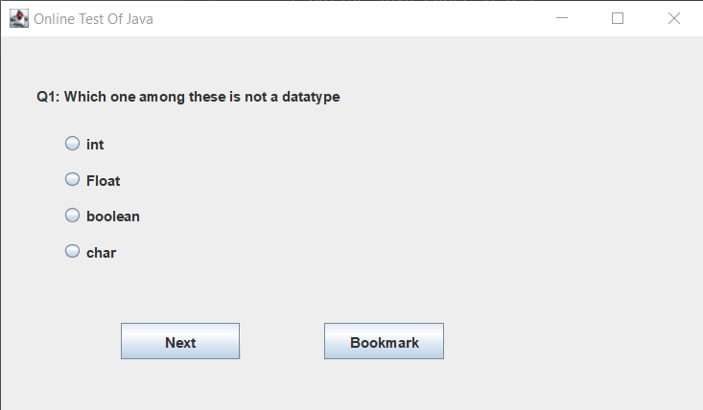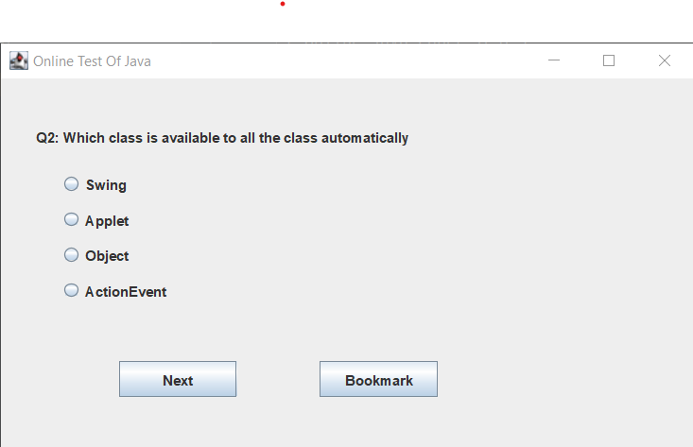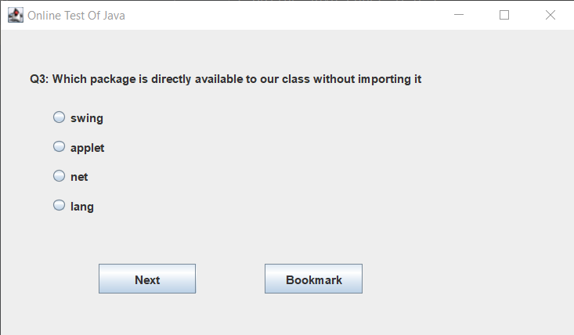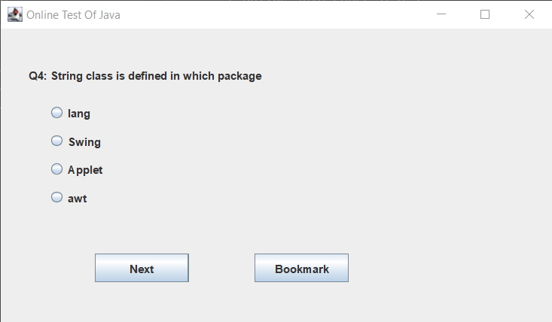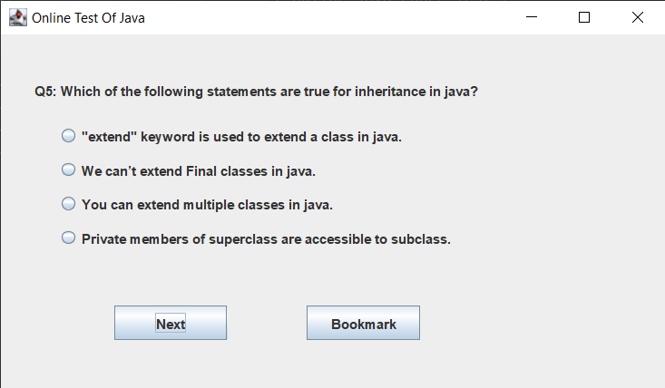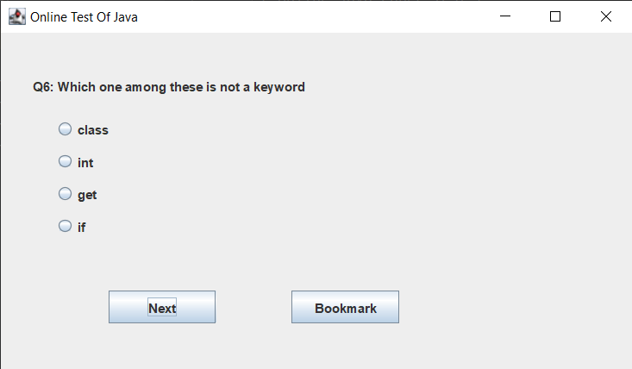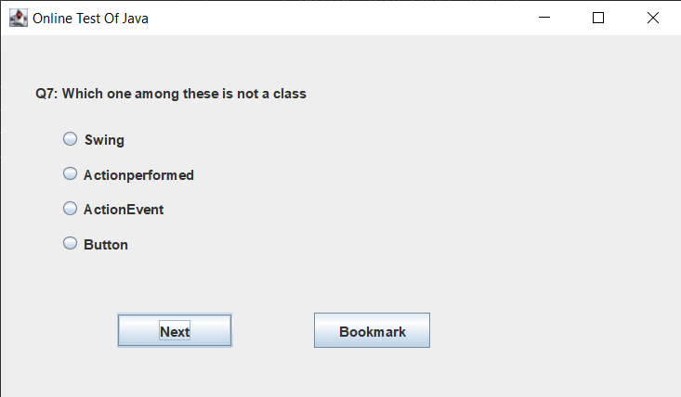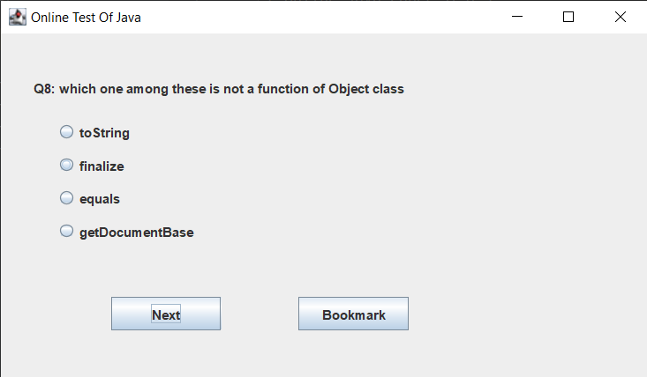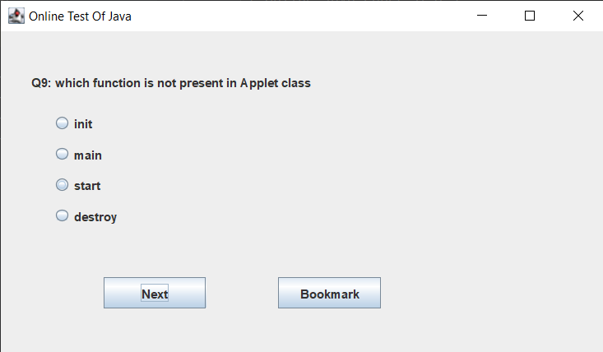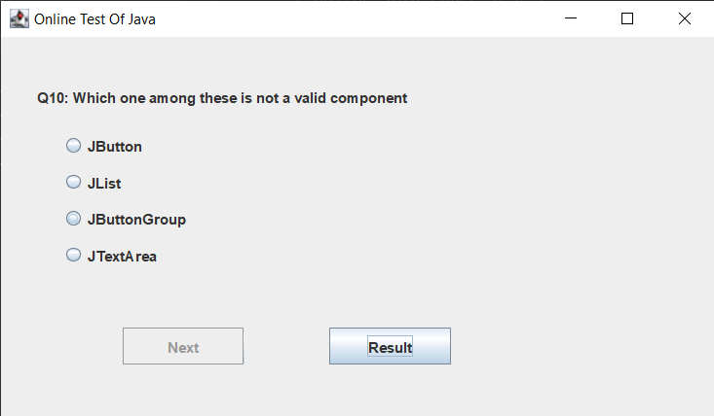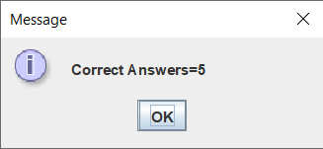

**CODE:**

/*Online Java Paper Test*/  
  
import java.awt.*;  
import java.awt.event.*;  
import javax.swing.*;  
  
class OnlineTest extends JFrame implements ActionListener  
{  
 JLabel l;  
 JRadioButton jb[]=new JRadioButton[5];  
 JButton b1,b2;  
 ButtonGroup bg;  
 int count=0,current=0,x=1,y=1,now=0;  
 int m[]=new int[10];  
 OnlineTest(String s)  
 {  
 super(s);  
 l=new JLabel();  
 add(l);  
 bg=new ButtonGroup();  
 for(int i=0;i<5;i++)  
 {  
 jb[i]=new JRadioButton();  
 add(jb[i]);  
 bg.add(jb[i]);  
 }  
 b1=new JButton("Next");  
 b2=new JButton("Bookmark");  
 b1.addActionListener(this);  
 b2.addActionListener(this);  
 add(b1);add(b2);  
 set();  
 l.setBounds(30,40,450,20);  
 jb[0].setBounds(50,80,100,20);  
 jb[1].setBounds(50,110,100,20);  
 jb[2].setBounds(50,140,100,20);  
 jb[3].setBounds(50,170,100,20);  
 b1.setBounds(100,240,100,30);  
 b2.setBounds(270,240,100,30);  
 setDefaultCloseOperation(JFrame.*EXIT_ON_CLOSE*);  
 setLayout(null);  
 setLocation(250,100);  
 setVisible(true);  
 setSize(600,350);  
 }  
 public void actionPerformed(ActionEvent e)  
 {  
 if(e.getSource()==b1)  
 {  
 if(check())  
 count=count+1;  
 current++;  
 set();  
 if(current==9)  
 {  
 b1.setEnabled(false);  
 b2.setText("Result");  
 }  
 }  
 if(e.getActionCommand().equals("Bookmark"))  
 {  
 JButton bk=new JButton("Bookmark"+x);  
 bk.setBounds(480,20+30*x,100,30);  
 add(bk);  
 bk.addActionListener(this);  
 m[x]=current;  
 x++;  
 current++;  
 set();  
 if(current==9)  
 b2.setText("Result");  
 setVisible(false);  
 setVisible(true);  
 }  
 for(int i=0,y=1;i<x;i++,y++)  
 {  
 if(e.getActionCommand().equals("Bookmark"+y))  
 {  
 if(check())  
 count=count+1;  
 now=current;  
 current=m[y];  
 set();  
 ((JButton)e.getSource()).setEnabled(false);  
 current=now;  
 }  
 }  
  
 if(e.getActionCommand().equals("Result"))  
 {  
 if(check())  
 count=count+1;  
 current++;  
 //System.out.println("correct ans="+count);  
 JOptionPane.*showMessageDialog*(this,"Correct Answers="+count);  
 System.*exit*(0);  
 }  
 }  
 void set()  
 {  
 jb[4].setSelected(true);  
 if(current==0)  
 {  
 l.setText("Q1: Which one among these is not a datatype");  
 jb[0].setText("int");jb[1].setText("Float");jb[2].setText("boolean");jb[3].setText("char");  
 }  
 if(current==1)  
 {  
 l.setText("Q2: Which class is available to all the class automatically");  
 jb[0].setText("Swing");jb[1].setText("Applet");jb[2].setText("Object");jb[3].setText("ActionEvent");  
 }  
 if(current==2)  
 {  
 l.setText("Q3: Which package is directly available to our class without importing it");  
 jb[0].setText("swing");jb[1].setText("applet");jb[2].setText("net");jb[3].setText("lang");  
 }  
 if(current==3)  
 {  
 l.setText("Q4: String class is defined in which package");  
 jb[0].setText("lang");jb[1].setText("Swing");jb[2].setText("Applet");jb[3].setText("awt");  
 }  
 if(current==4)  
 {  
 l.setText("Q5: Which of the following statements are true for inheritance in java?");  
 jb[0].setText("\"extend\" keyword is used to extend a class in java.");jb[1].setText("We can’t extend Final classes in java.");jb[2].setText("You can extend multiple classes in java.");jb[3].setText("Private members of superclass are accessible to subclass.");  
 }  
 if(current==5)  
 {  
 l.setText("Q6: Which one among these is not a keyword");  
 jb[0].setText("class");jb[1].setText("int");jb[2].setText("get");jb[3].setText("if");  
 }  
 if(current==6)  
 {  
 l.setText("Q7: Which one among these is not a class ");  
 jb[0].setText("Swing");jb[1].setText("Actionperformed");jb[2].setText("ActionEvent");jb[3].setText("Button");  
 }  
 if(current==7)  
 {  
 l.setText("Q8: which one among these is not a function of Object class");  
 jb[0].setText("toString");jb[1].setText("finalize");jb[2].setText("equals");jb[3].setText("getDocumentBase");  
 }  
 if(current==8)  
 {  
 l.setText("Q9: which function is not present in Applet class");  
 jb[0].setText("init");jb[1].setText("main");jb[2].setText("start");jb[3].setText("destroy");  
 }  
 if(current==9)  
 {  
 l.setText("Q10: Which one among these is not a valid component");  
 jb[0].setText("JButton");jb[1].setText("JList");jb[2].setText("JButtonGroup");jb[3].setText("JTextArea");  
 }  
 l.setBounds(30,40,450,20);  
 for(int i=0,j=0;i<=90;i+=30,j++)  
 jb[j].setBounds(50,80+i,500,20);  
 }  
 boolean check()  
 {  
 if(current==0)  
 return(jb[1].isSelected());  
 if(current==1)  
 return(jb[2].isSelected());  
 if(current==2)  
 return(jb[3].isSelected());  
 if(current==3)  
 return(jb[0].isSelected());  
 if(current==4)  
 return(jb[1].isSelected());  
 if(current==5)  
 return(jb[2].isSelected());  
 if(current==6)  
 return(jb[1].isSelected());  
 if(current==7)  
 return(jb[3].isSelected());  
 if(current==8)  
 return(jb[1].isSelected());  
 if(current==9)  
 return(jb[2].isSelected());  
 return false;  
 }  
 public static void main(String s[])  
 {  
 new OnlineTest("Online Test Of Java");  
 }  
  
  
}

**References:**

* Class notes
* [www.javatpoint.com](http://www.javatpoint.com)
* [www.w3schools.com](http://www.w3schools.com)
* [www.geeksforgeeks.com](http://www.geeksforgeeks.com)
* [www.sanfoundry.com](http://www.sanfoundry.com)
* and other internet sources